# PRACTICAL No. 1

**Aim:** 2D Linear Convolution, Circular Convolution between two 2D matrices.

**2D Linear Convolution Example 1:**

**Code:**

clc; x=[4,5,6;7,8,9]; h=[1;1;1];

disp(x,"x=");

disp(h,"h="); y=conv2(x,h);

disp(y, '2D Linear Convolution result: y =' );

## Output:

x=

4. 5. 6.

7. 8. 9.

h=

1.

1.

1.

2D Linear Convolution result: y =

|  |  |  |
| --- | --- | --- |
| 4. | 5. | 6. |
| 11. | 13. | 15. |
| 11. | 13. | 15. |
| 7. | 8. | 9. |

## Example 2:

**Code:**

clc; x=[1,2,3;4,5,6;7,8,9];

h=[1,1;1,1;1,1];

disp(x,"x=");

disp(h,"h="); y=conv2(x,h);

disp(y, '2D Linear Convolution result: y =' );

## Output:

x=

1. 2. 3.

4. 5. 6.

7. 8. 9.

h=

|  |  |
| --- | --- |
| 1. | 1. |
| 1. | 1. |
| 1. | 1. |

2D Linear Convolution result: y = 1. 3. 5. 3.

5. 12. 16. 9.

12. 27. 33. 18.

11. 24. 28. 15.

7. 15. 17. 9.

## 2D Circular Convolution Example 1:

**Code:**

clc ; x=[1,2;3,4];

h=[5,6;7,8];

disp(x,'x=');

disp(h,'h='); X=fft2(x); H=fft2(h); Y=X.*H;

y=ifft(Y);

disp(y, '2D Circular Correlation Result: y =' );

## Output:

x=

1. 2.

3. 4.

h=

5. 6.

7. 8.

2D Circular Correlation Result: y = 70. 68.

62. 60.

## Example 2:

**Code:**

clc ; x=[1,2,3;4,5,6;7,8,9];

h=[1,1,1;1,1,1;1,1,1];

disp(x,'x=');

disp(h,'h='); X=fft2(x); H=fft2(h); Y=X.*H;

y=ifft(Y);

disp(y, '2D Circular Correlation Result: y =' );

## Output:

x=

1. 2. 3.

4. 5. 6.

7. 8. 9.

h=

1. 1. 1.

1. 1. 1.

1. 1. 1.

2D Circular Correlation Result: y =

|  |  |  |
| --- | --- | --- |
| 45. | 45. | 45. |
| 45. | 45. | 45. |
| 45. | 45. | 45. |

# PRACTICAL No. 2

**Aim:** Circular Convolution expressed as Linear Convolution plus alias.

**Code:**

clc ;

x =[1,2;3,4];

h=[5,6;7,8];

y=conv2(x,h); y1=[y(:,1)+y(:,$),y(:,2) ];

y2=[y1(1,:)+y1($,:);y1(2,:)];

disp(y, 'Linear Convolution Result: y=');

disp(y2 , 'Circular Convolution expressed as Linear Convolution =' );

## Output:

Linear Convolution Result: y=

5. 16. 12.

22. 60. 40.

21. 52. 32.

Circular Convolution expressed as Linear Convolution = 70. 68.

62. 60.

# PRACTICAL No. 3

**Aim:** Linear Cross correlation of a 2D matrix, Circular correlation between two signals and Linear auto correlation of a 2D matrix, Linear Cross correlation of a 2D matrix

1. **Linear Cross correlation of a 2D matrix Code:**

clc;

x = [3,1;2,4];

h1 = [1,5;2,3];

h2 = h1(:,$:-1:1);

h = h2($:-1:1,:);

y = conv2(x,h)

disp(y, 'Linear cross Correlation result y=')

## Output:

Linear cross Correlation result y= 9. 9. 2.

21. 24. 9.

10. 22. 4.

## Circular correlation between two signals Code:

clc;

x = [1,5;2,4];

h = [3,2;4,1];

h = h(:,$:-1:1);

h = h($:-1:1,:);

X = fft2(x); H = fft2(h); Y = X.*H;

y = ifft(Y);

disp(y,'Circular Correlation result y=')

## Output:

Circular Correlation result y= 37. 23.

35. 25.

## Linear auto correlation of a 2D matrix

**Code:**

clc;

x1 = [1,1;1,1];

x2 = x1(:,$:-1:1);

x2 = x2($:-1:1,:);

x = conv2(x1,x2)

disp(x,'Linear auto Correlation result x=')

## Output:

Linear auto Correlation result x= 1. 2. 1.

2. 4. 2.

1. 2. 1.

## Linear Cross correlation of a 2D matrix Code:

clc;

x = [1,1;1,1];

h1 = [1,2;3,4];

h2 = h1(:,$:-1:1);

h = h2($:-1:1,:);

y = conv2(x,h)

disp(y, ' Linear cross Correlation result y=')

## Output:

Linear cross Correlation result y= 4. 7. 3.

6. 10. 4.

2. 3. 1.

# PRACTICAL No. 4

**Aim:** Perform DFT of a 4x4 gray scale image.

## Code:

clc; x=[1,1,1,1;1,1,1,1;1,1,1,1;1,1,1,1];

X=fft(x,-1); disp(X,"X[k]=");

## Output:

X[k]=

|  |  |  |  |
| --- | --- | --- | --- |
| 16. | 0. | 0. | 0. |
| 0. | 0. | 0. | 0. |
| 0. | 0. | 0. | 0. |
| 0. | 0. | 0. | 0. |

# PRACTICAL No. 5

## AIM:- Compute discrete cosine transform, Program to perform KL transform for the given 2D matrix.

**Code:-**

clear; clc;

X=[4,3,5,6;4,2,7,7;5,5,6,7];

[m,n]=size(X);

A=[];

E=[];

for i=1:n A=A+X(:,i); E=E+X(:,i)*X(:,i)';

end mx=A/n; E=E/n;

C=E-mx*mx'; [V,D]=spec(C);

d=diag(D); [d,i]=gsort(d); for j=1:length(d)

T(:,j)=V(:,i(j));

end T=T'

disp(d,' Eigen Values are U = ') disp(T,'The eigen vector matrix T =') disp(T,'The KL tranform basis is =') for i=1:n

Y(:,i)=T*X(:,i);

end

disp(Y,'KL transformation of the input matrix Y =') for i=1:n

x(:,i)=T'*Y(:,i);

end

disp(x,'Reconstruct matrix of the given sample matrix X =')

## Output:-

Eigen Values are U = 6.1963372

0.2147417

0.0264211

The eigen vector matrix T =

|  |  |  |
| --- | --- | --- |
| 0.4384533 | 0.8471005 | 0.3002988 |
| 0.4460381 | - 0.4951684 | 0.7455591 |
| - 0.7802620 | 0.1929481 | 0.5949473 |

The KL tranform basis is =

|  |  |  |
| --- | --- | --- |
| 0.4384533 | 0.8471005 | 0.3002988 |
| 0.4460381 | - 0.4951684 | 0.7455591 |
| - 0.7802620 | 0.1929481 | 0.5949473 |

KL transformation of the input matrix Y =

|  |  |  |  |
| --- | --- | --- | --- |
| 6.6437095 | 4.5110551 | 9.9237632 | 10.662515 |
| 3.5312743 | 4.0755729 | 3.2373664 | 4.4289635 |
| 0.6254808 | 1.0198466 | 1.0190104 | 0.8336957 |

Reconstruct matrix of the given sample matrix X =

|  |  |  |  |
| --- | --- | --- | --- |
| 4. | 3. | 5. | 6. |
| 4. | 2. | 7. | 7. |
| 5. | 5. | 6. | 7. |

# PRACTICAL No. 6

## AIM:- Brightness enhancement of an image, Contrast Manipulation, image negative.

Install Image Processing and Signal Processing packages and restart scilab. Run this command on console: atomsRemove('scicv')

Restart scilab And run code

## Brightness Enhancement

Code:-

Clc; close;

a=imread('C:\Users\ADMIN\Desktop\flower.jpg'); a=rgb2gray(a);

b=double(a)+50; b=uint8(b); figure(1); imshow(a);

title("Original Image") figure(2);

imshow(b); title("Enhanced Image")

## Output:-

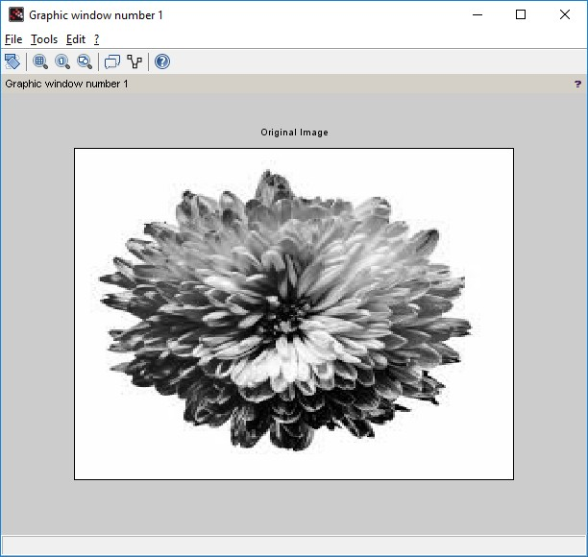

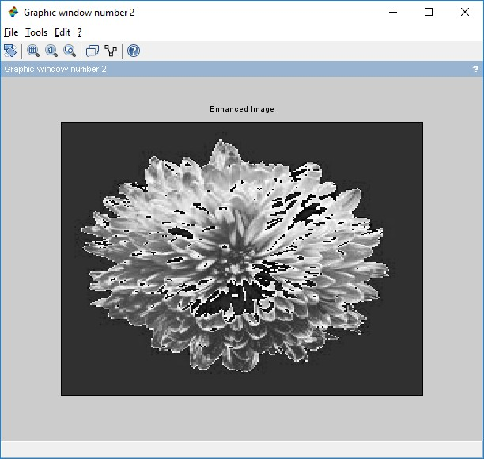

**Contrast Manipulation**

clc ; close ;

a = imread('C:\Users\ADMIN\Desktop\flower.jpg'); a = rgb2gray(a);

b = double(a)*0.5; b = uint8 (b)

c = double(b)*2; c = uint8(c) figure(1) imshow(a);

title('Original Image') figure(2)

imshow(b); title('Decreased Contrast' ) figure(3)

imshow(c); title('Increased Contrast')

## Output:-



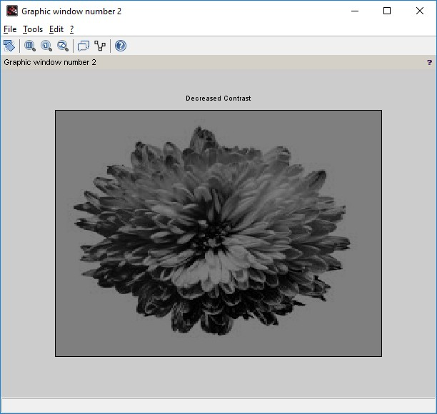

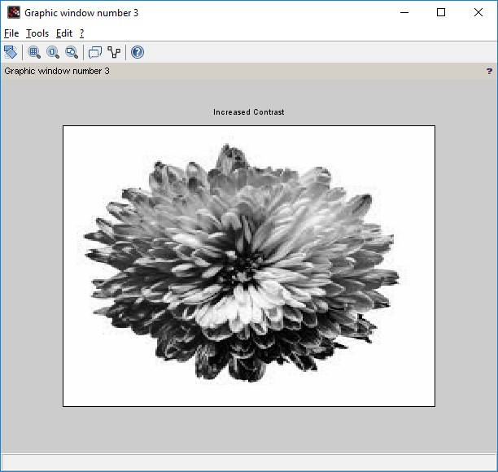

**Image Negative**

Code:- clc; close;

a = imread('C:\Users\ADMIN\Desktop\flower.jpg'); k = 255-double(a);

k = uint8(k); figure(1) imshow(a);

title('Original Image') figure(2)

imshow(k);

title('Negative of Original Image')

**Output:**

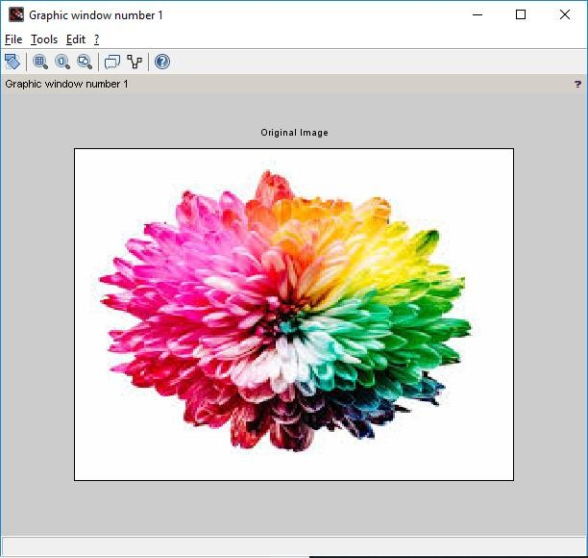

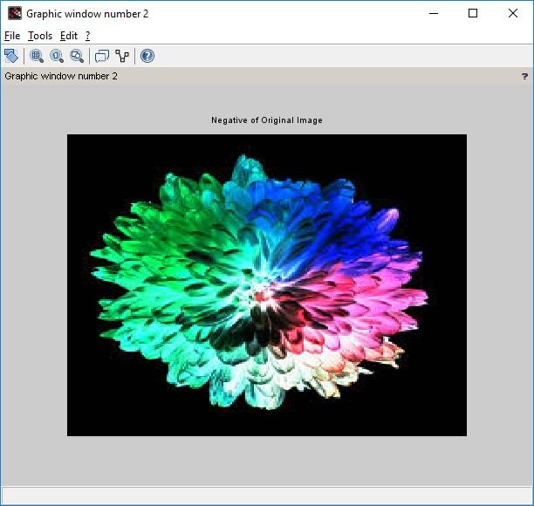

# PRACTICAL No. 7

## AIM:- Perform threshold operation, perform gray level slicing without background.

Install Image Processing and Signal Processing packages and restart scilab. Run this command on console: atomsRemove('scicv')

Restart scilab And run code

## Threshold Operation Code:-

clc; close;

a = imread('C:\Users\ADMIN\Desktop\flower.jpg'); a = rgb2gray(a);

[m n] = size(a);

t = input('Enter threshold parameter: '); for i = 1:m

for j = 1:n if(a(i,j)<t)

b(i,j)=0; else

b(i,j) =255;

end end

end figure(1) imshow(a);

title('Original Image') figure(2)

imshow(b); title('Threshold Image')

xlabel(sprintf('Threshold Value is %g ',t))

## Output:

**Enter threshold parameter: 140**



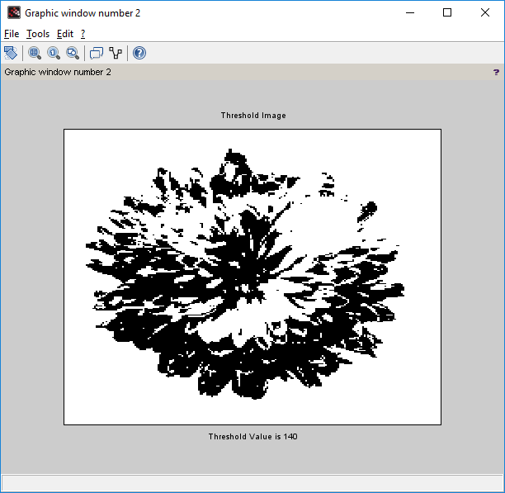

**Gray Level Scaling without background. Code:-**

clc ;

x = imread('C:\Users\ADMIN\Desktop\flower.jpg'); x = rgb2gray(x);

y = double(x); [m,n]= size(y);

L = max(max(x)); a = round(L/2) ;

b = L;

for i =1: m for j =1: n

if(y(i,j)>=a & y(i,j)<=b) z(i,j) = L;

else

z(i,j)=0; end

end end

z = uint8(z); figure(1) imshow(x);

title('Original Image') figure(2)

imshow(z);

title('Gray Level Slicing without preserving background')

**Output:**



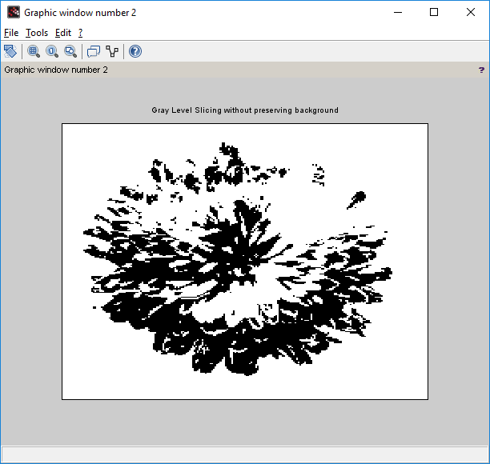

# PRACTICAL No. 8

**AIM:- Image Segmentation.**

Install Image Processing and Signal Processing packages and restart scilab. Run this command on console: atomsRemove('scicv')

Restart scilab And run code

1. Differentiation of Gaussian function. clc ;

close ;

sigma = input('Enter the value of sigma: ') i = -10:.1:10;

j = -10:.1:10;

r = sqrt(i.*i+j.*j);

y = (1/(sigma^2))*(((r.*r)/sigma^2)-1) .* exp(-r.*r/2*sigma^2); plot(i,y)

legend(sprintf('The sigma value is %g',sigma)) xtitle('Differentiation of Gaussian function')

**Output:-**

**Enter the value of sigma: 1**

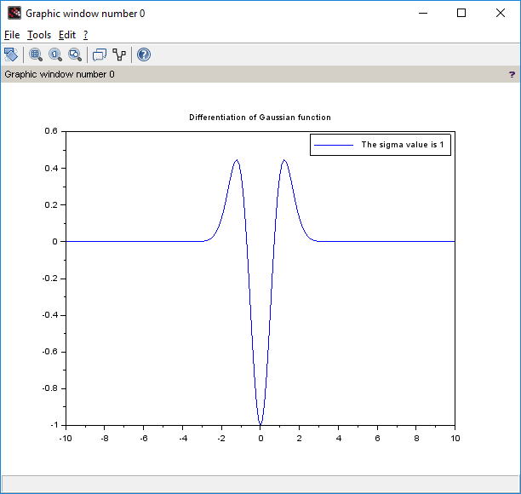

1. Differentiation of Gaussian Filter function

clc ; close ;

sigma1 = input('Enter the value of sigma1: ') sigma2 = input ('Enter the value of sigma2: ') i = -10:.1:10;

j = -10:.1:10;

r = sqrt(i.*i+j.*j);

y1 = (1/( sigma1^2))*(((r.*r)/sigma1^2)-1) .* exp(-r.*r/2*sigma1^2); y2 = (1/( sigma2^2))*(((r.*r)/sigma2^2)-1) .* exp(-r.*r/2*sigma2 ^2); y = y1-y2;

plot(i,y)

xtitle('Shape of DOG Filter ')

**Output:**

**Enter the value of sigma1: 4 Enter the value of sigma2: 1**

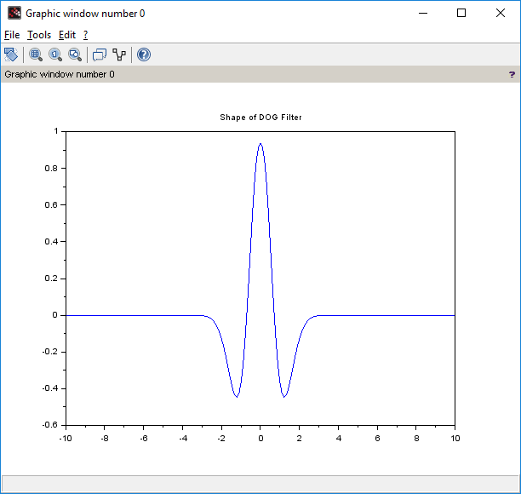

1. Edge Detection using Different Edge detectors

close ; clc ;

a = imread('C:\Users\ADMIN\Desktop\flower.jpg'); a = rgb2gray(a);

c = edge(a,'sobel');

d = edge(a,'prewitt'); e = edge(a,'log');

f = edge (a,'canny'); imshow(a) title('Original Image') figure

imshow(c) title('Sobel') figure imshow(d) title('prewitt') figure imshow(e) title('Log') figure imshow(f) title('Canny')

**Output:**

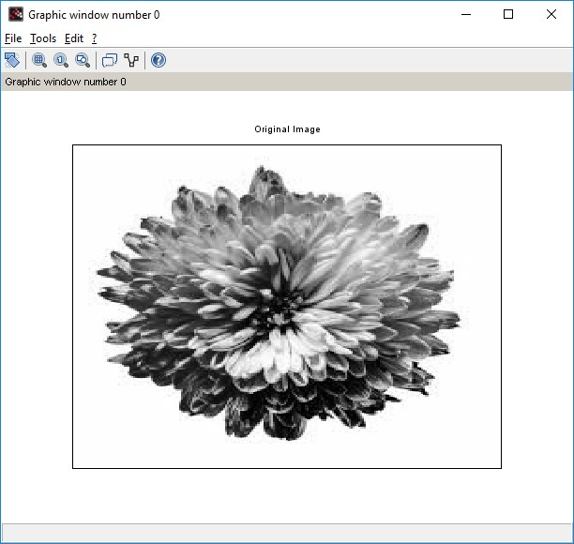

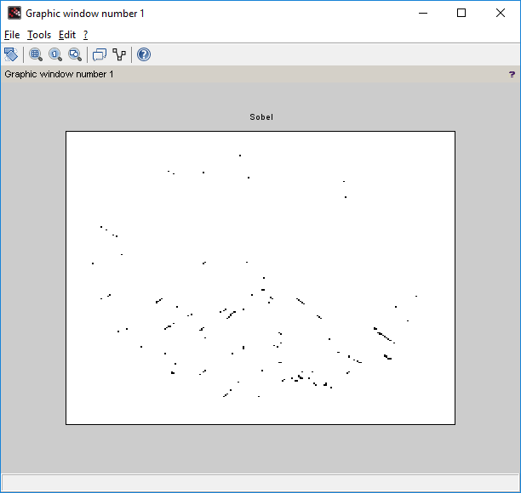

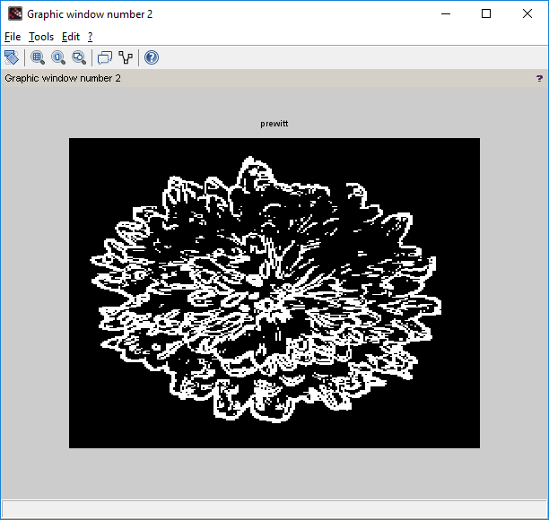

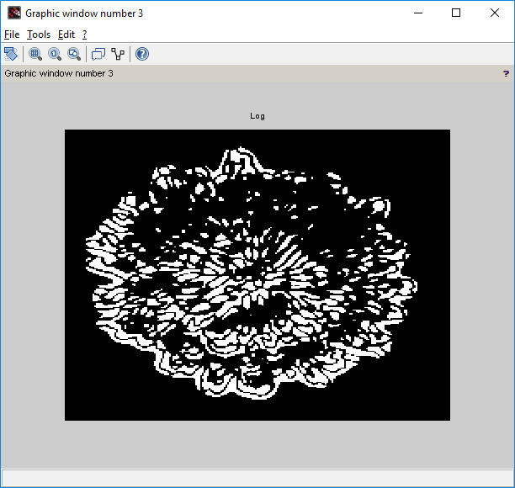

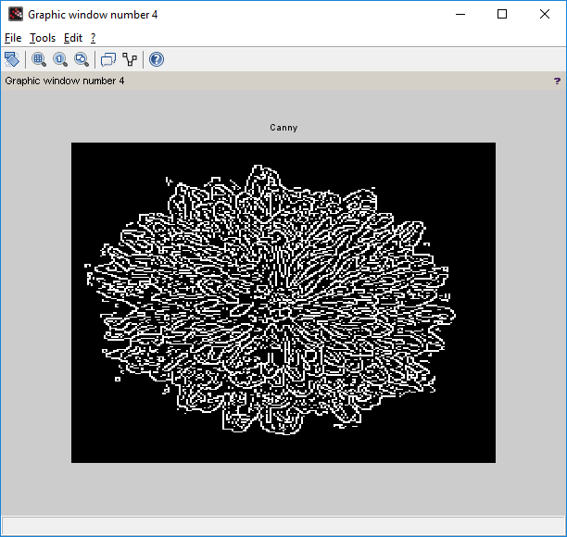

# PRACTICAL No. 9

**AIM:- Image Compression.**

Install Image Processing and Signal Processing packages and restart scilab. Run this command on console: atomsRemove('scicv')

Restart scilab And run code

* 1. Block Truncation Coding BTC (Output in the form of Matrix).

**Code:-**

close; clear; clc;

x=[65,75,80,70;72,75,82,68;84,72,62,65;66,68,72,80];

disp(x,"Original Block is x = " ); [ m1 n1 ] = size(x);

blk = input("Enter the block size: "); for i = 1:blk:m1

for j = 1:blk:n1

y = x(i:i+(blk-1),j:j+(blk -1)); m = mean(mean(y)); disp(m,"mean value is m = "); sig = stdev(y);

disp(sig,"Standard deviation of the block is = "); b = y>m;

disp(b,"Binary allocation matrix is B= "); K = sum(sum(b));

disp(K,"number of ones = "); if(K~=blk^2)&( K~=0)

ml = m-sig*sqrt(K/((blk^2)-K)); disp(ml,"The value of a = ");

mu = m+sig*sqrt(((blk^2)-K)/K); disp(mu,"The value of b = ");

x(i:i+(blk-1),j:j+(blk-1))=b*mu+(1-b)*ml; end

end end

disp(round(x),"Reconstructed Block is x = " );

**Output**

**Original Block is x = 65. 75. 80. 70.**

**72. 75. 82. 68.**

**84. 72. 62. 65.**

**66. 68. 72. 80.**

**Enter the block size: 4**

**mean value is m = 72.25**

**Standard deviation of the block is = 6.6282225**

**Binary allocation matrix is B=**

**F T T F F T T F T F F F F F F T**

**number of ones = 6.**

**The value of a = 67.115801**

**The value of b = 80.806998**

**Reconstructed Block is x =**

|  |  |  |  |
| --- | --- | --- | --- |
| **67.** | **81.** | **81.** | **67.** |
| **67.** | **81.** | **81.** | **67.** |
| **81.** | **67.** | **67.** | **67.** |
| **67.** | **67.** | **67.** | **81.** |

# PRACTICAL No. 10

## AIM:- Binary Image Processing and Colour Image processing.

Install Image Processing and Signal Processing packages and restart scilab. Run this command on console: atomsRemove('scicv')

Restart scilab And run code

1. Dilation and erosion process.

**Code:-** close ; clear ; clc ;

a = imread('C:\Users\ADMIN\Desktop\letter.png');

b = imcreatese('rect',7,7); *//Structuring element value can be either rect, ellipse, cross*

a1 = imdilate(a,b); a2 = imerode(a,b); figure(1) imshow(a);

title('Original Image') figure(2) imshow(a1); title('Dilated Image') figure(3) imshow(a2); title('Eroded Image')

**Output:-**

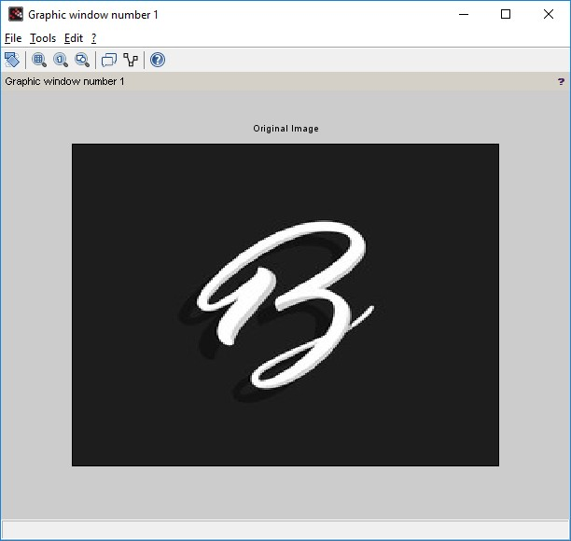

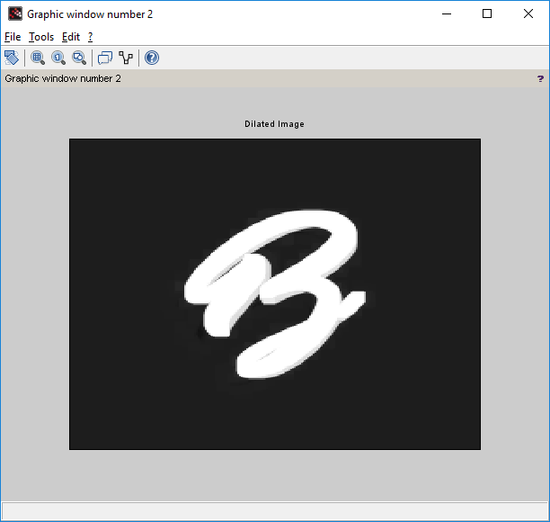

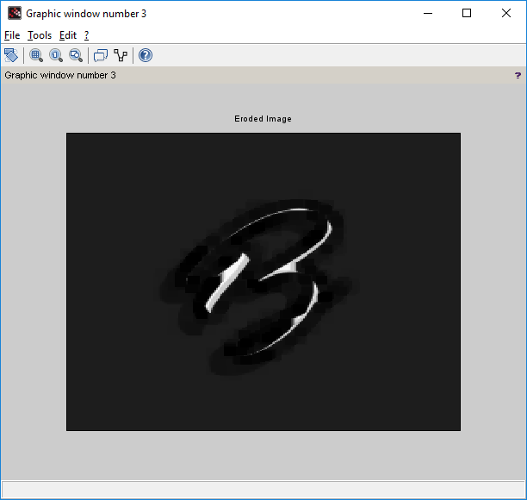

1. opening and closing operation on the image.

Code:- close ; clear ; clc ;

a = imread('C:\Users\ADMIN\Desktop\letter.png');

b = imcreatese('rect',7,7); *//Structuring element value can be either rect, ellipse, cross*

a1 = imopen(a,b); a2 = imclose(a,b); figure(1) imshow(a);

title('Original Image') figure(2) imshow(a1);

title('Opening Operation') figure(3)

imshow(a2); title('Closing Operation')

**Output:-**



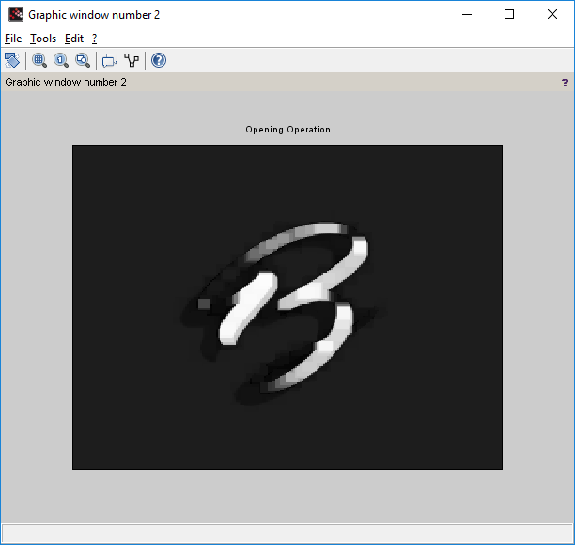

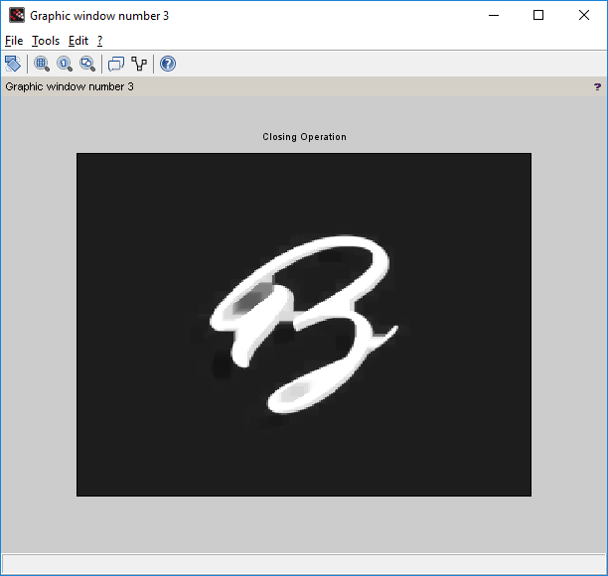

1. Read an RGB image and extract the three colour components red, green and blue.

Code:-

clc; close ;

RGB = imread('C:\Users\ADMIN\Desktop\flower.jpg'); R = RGB;

G = RGB; B = RGB; R(: ,: ,2) =0;

R(: ,: ,3) =0;

G(: ,: ,1) =0;

G(: ,: ,3) =0;

B(: ,: ,1) =0;

B(: ,: ,2) =0;

figure(1) imshow(RGB);

title('Original Color Image'); figure(2)

imshow(R);

title('Red Component'); figure(3)

imshow(G);

title('Green Component'); figure(4)

imshow(B);

title('Blue Component')

**Output:-**

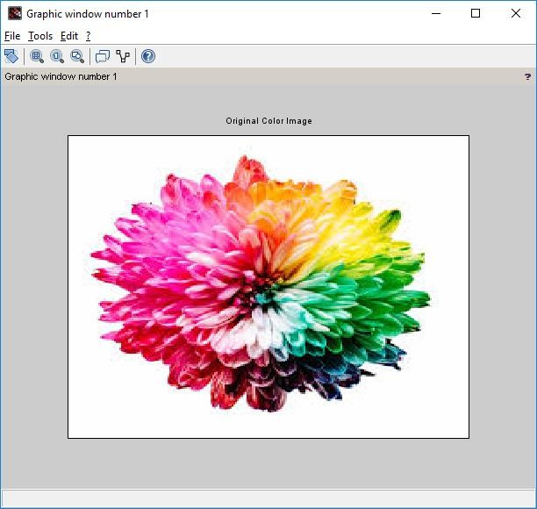

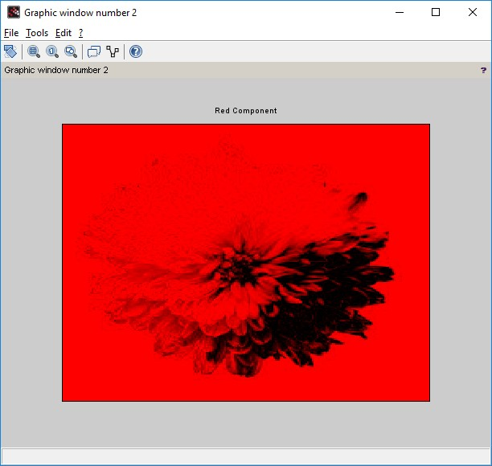

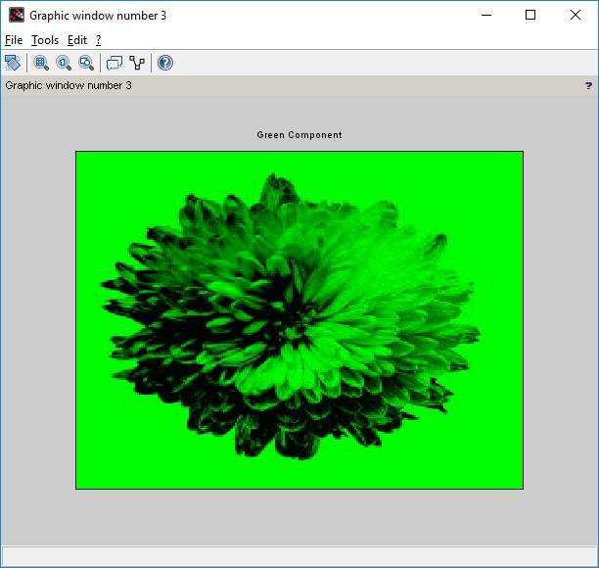

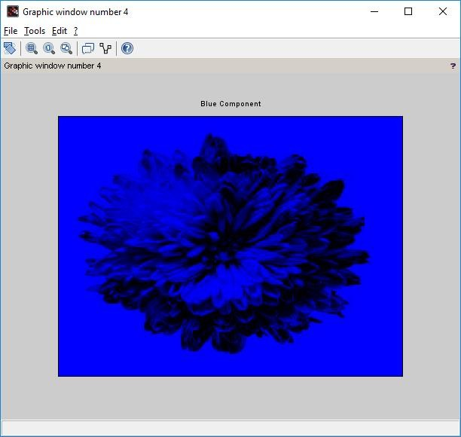

1. Read a Colour image and separate the colour image into red green and blue planes.

Code:-

clc; close ;

RGB = imread('C:\Users\ADMIN\Desktop\flower.jpg'); R = RGB;

G = RGB; B = RGB; R(: ,: ,1) =0;

G(: ,: ,2) =0;

B(: ,: ,3) =0;

figure(1) imshow(RGB);

title('Original Color Image'); figure(2)

imshow(R);

title('Red Component Missing'); figure(3)

imshow(G);

title('Green Component Missing'); figure(4)

imshow(B);

title('Blue Component Missing')

Output:-

